11. Create a DataFrame of ten rows and four columns with random values. Convert some values to NaN values. Write a Pandas program to highlight the NaN values.
Aim
The aim of this program is to create a Pandas DataFrame with 10 rows and 4 columns containing random values, replace some values with NaN (Not a Number) to represent missing data, and highlight the NaN values using Pandas Styling for easy identification and analysis of missing data.
PROGRAM:
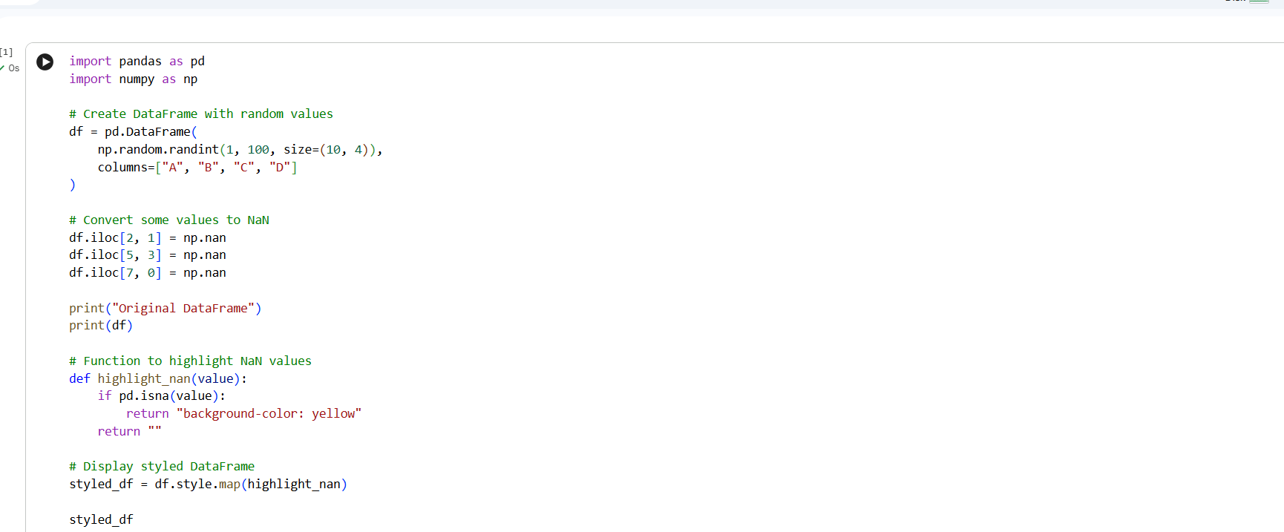
OUTPUT:
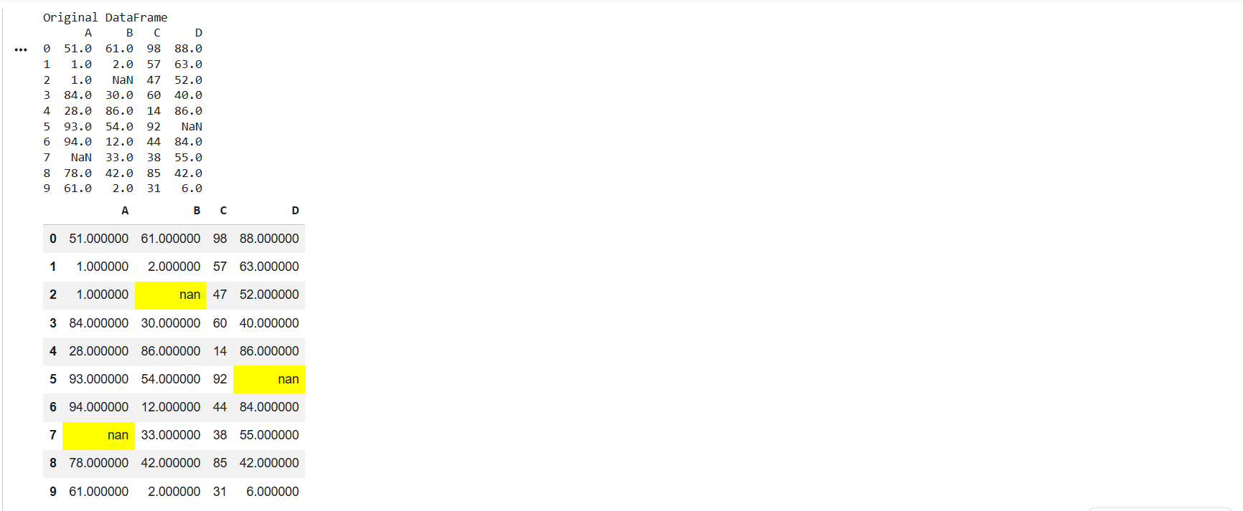
Result:
The DataFrame with 10 rows and 4 columns was created successfully using random values. Some values were replaced with NaN (Not a Number), and the NaN values were successfully highlighted using Pandas Styling, making it easy to identify missing data.

12. Create a DataFrame of ten rows and four columns with random values. Write a Pandas program to set the DataFrame background color black and font color yellow.
Aim
The aim of this program is to create a Pandas DataFrame containing 10 rows and 4 columns with random values and apply Pandas Styling to set the background color to black and the font color to yellow, thereby improving the visual appearance of the DataFrame.
Program:
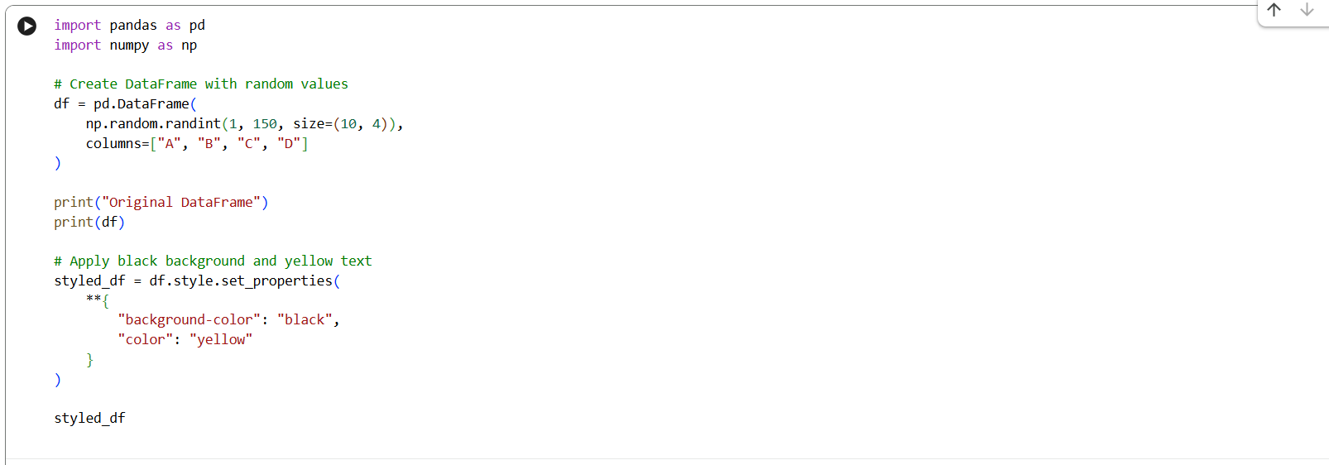
OUTPUT:
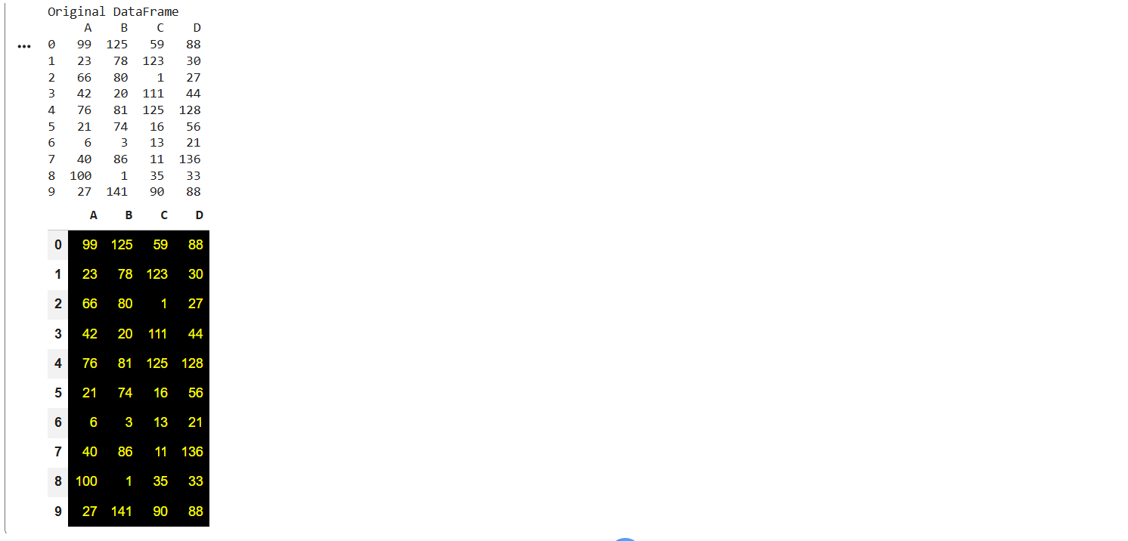
Result:
The DataFrame with 10 rows and 4 columns containing random values was created successfully. The DataFrame was displayed with a black background and yellow font color using Pandas Styling, enhancing the visual appearance of the data.

